**Analysis of the Outputs from Scheduling Algorithms**

For the scheduling algorithm code:

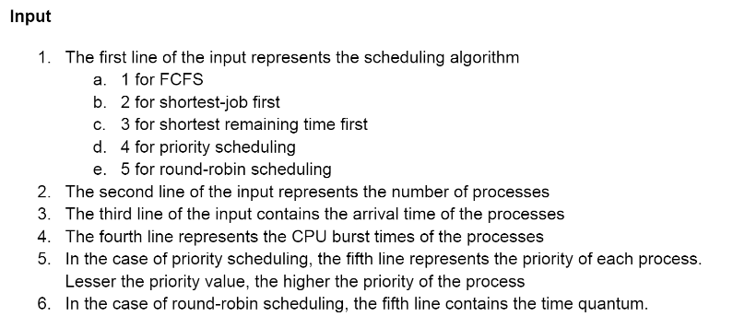

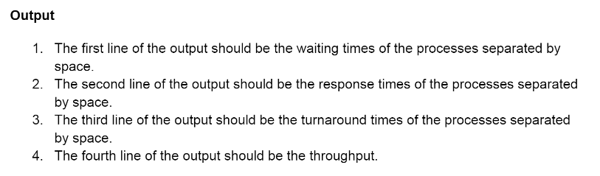

* **FCFS Method Outputs:**

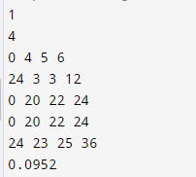

As we can see in the above image, the FCFS waiting time and response times of the processes are very high. This method is not the best for scheduling

* **SJF Method Outputs**

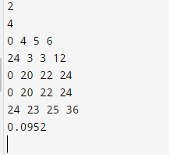

As we can see in the above image, the waiting time and response times are similar to the FCFS scheduling method. This method is not the best.

* **PS Method Outputs**

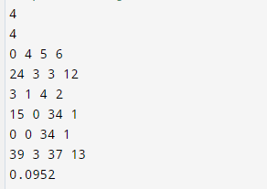

The waiting times and the response times are slightly better than the other algorithms. But, we do have processes where the response times are very high.

* **Round Robin Outputs**

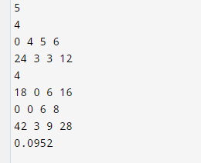

The waiting times and the response times have improved. This method is the best out of the 4 scheduling algorithms for this problem.

**ROUND ROBIN IS THE BEST IN THE ABOVE QUESTION**